# Chapter 1: Introduction

My project will be on the topic Online liquor store. I am going to develop a commercial website for my liquor store which will be helpful for my shop’s customers.

* 1. Introduction:

The name of my project will be on the topic Brindavan Traders, a liquor store which supplies varieties of imported liquors and spirits as well. In this present situation, people are seeking for an easy and reliable means of trade with the medium of internet. People are being lazy to get to the store and buy the goods & product they need. By doing this project, this will help for our regular as well as for new customers to get their desire safe goods which are available in our store.

* 1. Background of the project:

This project will be based on the buying and selling of varieties of liquors available in the store.

With help of this project the customers will be able to buy the liquors by sitting at home where the customers can pay on delivery of the demand goods.

* 1. Problem Statement:

Our customers were having problem to travel long distance to buy our goods. This project will help our customers to choose the liquor and buy it online. Our customers will have a problem of paying through various online payment methods.

* 1. Description of the project:

This project will be based on commercial purpose for my shop. On the advice of customers of our shop, I have decided to do this topic for my project which will be helpful for our shop. It will also help not only for our regular customers but also for our new customers who are looking for a quality and reasonable goods at their home through advertisement via internet.

* + 1. Features of the project:
* Details of various liquors with price.
* Customers can make an order online and make payment on delivery.
* Register and sign in features will also be included.
* Customers can get connected through Facebook, viber also Instagram.
* Membership features will be provided with certain discount percentage.
  1. Overview of the project:

This project will be useful for not my liquor shop but also for other various shop like departmental store, super market, wholesale, etc. My project will be fully based on commercial purpose and also for advertisement purpose. The website will be very simple and easy to use where the background of our shop will be clearly displayed.

# Chapter 2: Scope of the project

## 2.1 Scope:

* Providing online trade to the customers.
* Providing overall description of the Spirits and liquor.
* To minimize the commission margin within the retailers.
* Very simple and user-friendly.

## 2.2 Limitations:

* Lacks of online payment system which will be upgraded in the future hopefully.
* Applicable only for this country presently.
* Will be useful only for spirits products only.

## 2.3 Aims:

* Providing the product as desire by the customer in easy way with reasonable price.
* Improving the interaction with the existing customers and attracting new customers as well.
* To Increase sales.

## 2.4 Objectives:

* Creating a proper login and signing up system.
* Improving the knowledge of computing language.
* Creating a suitable website for our liquor shop which will be an additional strategy.
* Better customer service.
* Sustainable rise.

## 2.5 overview of the scope:

In this world of internet and technology, the way of doing business has varied a lot. Various methods and techniques have been introducing to promote business. People these days are using the medium of internet i.e. e-commerce for their day to day purpose. This project will be an advantages for my shop and will be easy for customers to get through their required product within their home.

# Chapter 3: Development Methodology

## 3.1 Description of methodology:

For this project, I will be using waterfall model which is subsequent approach during the development of this project. The waterfall model indicates and maintain consistent advancement which was first introduced by Dr. Winston W. Royce. This process is separated into various phases and every phase needs to be completed to go onto next phase.

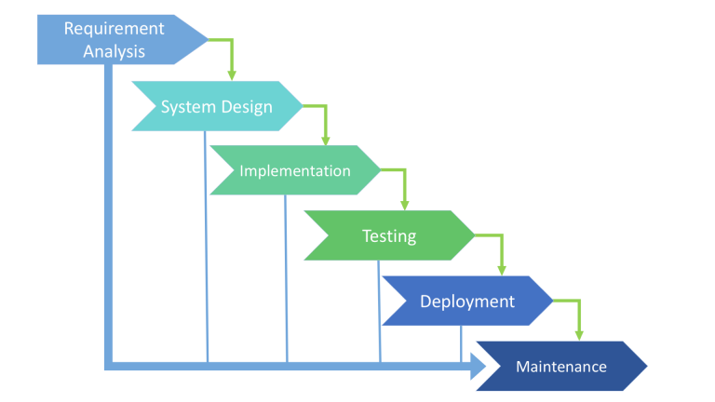

Advantages of using the waterfall model: -

* Every process of the stages is completed within a time.
* Suitable for smaller of project.
* Easily accessible and simple to understand.
* Milestone and deadlines are clearly defined.
* Easy to classify and give priority to task.
* The progresses are easily understandable and have explainable phases.

The phases under the waterfall model are discuss below: -

* **Requirement Analysis:**

All sorts of possible requirements are studied in this phase. It is an important phase during a project management. It deals with hardware, software and human factors with a team effort.

* **System Analysis:**

It is based on specifying hardware, system requirements and architecture. The things which need to be done in the next phase are discussed here.

* **Implementation:**

After system analysis, the system is now created by coding and integrated in the next phase.

* **Testing:**

The system which were created in the implementation phase are tested to find out if there are any errors or flaws. It is done to prevent any kind of problem during the installation process by the client.

* **Deployment:**

Once the functional and non-functional testing is done, the system is deployed in the market.

* **Maintenance:**

It is done when the system is installed, modification is done according to the need and demand of the client. If any errors or bugs arises they are solved during maintenance.

**Object-oriented Approach:**

It is a programming language which describes the way of designing the system architecture which uses certain patterns such as classes, objects, interfaces, abstraction, etc. to describe a software solution. It facilitates best quality software by minimizing the cost while creating a software. It is accepted widely as the powerful as well as important way of making a software.

**Design Pattern:**

Design patterns are the patterns which are used to represent the practices that are adapted by experienced object oriented software developers. It provides a proper description of the problem, solution and the appropriate time to used it also its consequences. It helps to show implementation clue and evidence for the mistakes or errors which may arise during the development period. By using the design pattern, the development process can be speed up going through various tested & proven development paradigms.

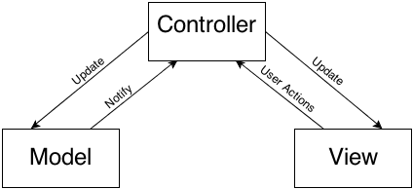

I will be using Model View controller(MVC) during the development process of this project. Here, the design patterns are separated into 3 relevant sections i.e. Model, View & Controller.

Benefits of using this pattern are: -

* Provides the appropriate way to solve issues during development cycle.
* Isolates the variability which may exist in the system requirement.
* Helps to speed up the development cycle by providing the required paradigms.
* Provides path to the developers to interact by using known understandable name for interaction while developing a software.

## Architecture:

I will be using the peer-to-peer architecture, which is simple and easily understandable used widely. P2P is suitable for single software program designed that provides the foundation of the network system with resources. It acts both as a client & server with certain responsibilities.

## Project Planning

## Work Breakdown Structure(WBS)

Every projects are built under certain criteria and stated time schedule. Projects are divided into several parts between the members involved in the project. The whole task needs to break down into numbers in order to finish the task in the given time. All the members involved in the project needs to finish their provided task in the stated date and time. That’s why to complete my project on the time I have break down my project task into different parts which I have listed down below: -

## Milestones:

After the project task is divided into several parts, each and every task should be given a required amount of time to finish it. To separate the time for every task Milestones is used to provide specific objective and time within the project timeline. Milestones are tools used in various kinds of project management for achievement of the project goal in a project timeline. So, to complete my project I have prepared a milestone listed below: -

|  |  |  |  |
| --- | --- | --- | --- |
| S/N | Milestones | Start date | Final date |
| 1 | Proposal  Introduction  Scope of the project  Development Methodology  Project planning  Risk Management  Configuration Management  Conclusion |  |  |
| 2 | Analysis  Architecture  Feasibility Study |  |  |
|  |  |  |  |
|  |  |  |  |
|  |  |  |  |
|  |  |  |  |

## 3.2

## Gantt Chart:

Gantt chart is a horizontal bar which was developed as a manufacturing control tool by an American engineer named Henry L. Gantt, social scientist. It helps to provide a graphical illustration of schedule which tends to help to coordinate, to plan, and also to track specific given tasks in a project. Gantt chart provides an overall view of the project status and helps to save time.

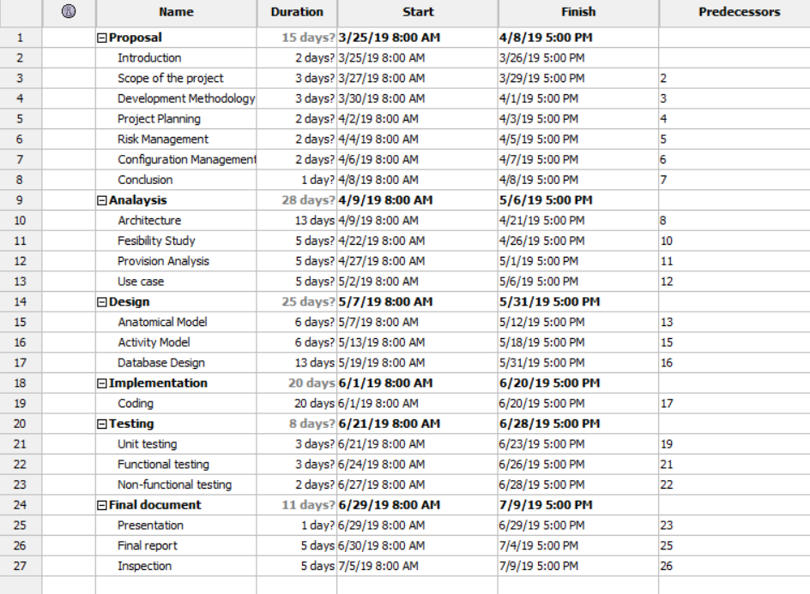

## C:\Users\Abhishek\Desktop\gann2.PNG

## Risk Management:

It can be defined as the procedure of finding out several kinds of errors or bugs which may or may not arise related to a project and providing the suitable solution to the errors. The process under this management system are identifying, assessing and controlling the hazard to a company’s income and capital. It should be closely aligned to the schedule management.

## Configuration Management:

Configuration management system is a mechanical method for controlling the computer system. It helps to keep the consistency of system and software. It helps to enable capacity for scaling infrastructure and software. Configuration Management deals with the state of any given infrastructure or software system within given period of time.

## Conclusion:

With the vision of creating the website for our shop, it be based on customer align methodology. For completing this project, I have estimated that it would be completed within 107 days. This project will be a plus point for commercializing our family business through the medium of e-commerce.

## Bibliography: